1. Loading the Data and Import Libraries

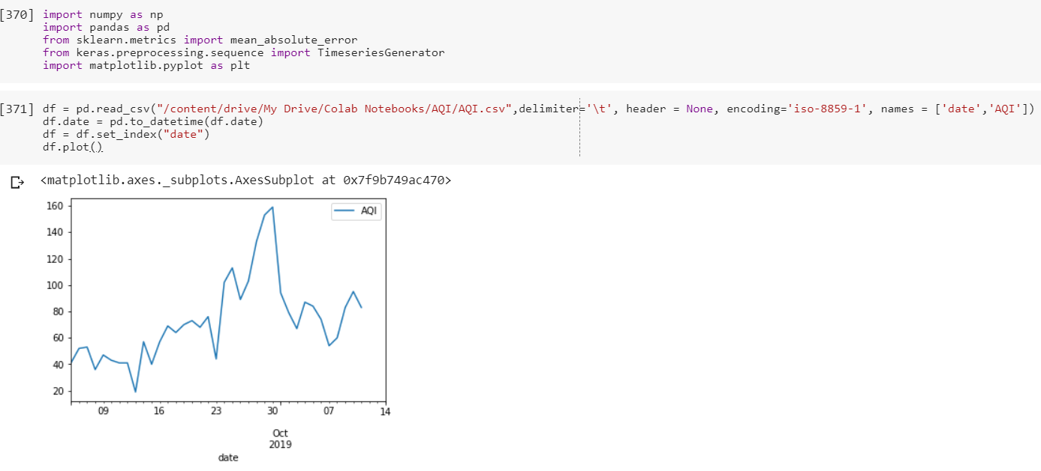

1. Exploring dataset

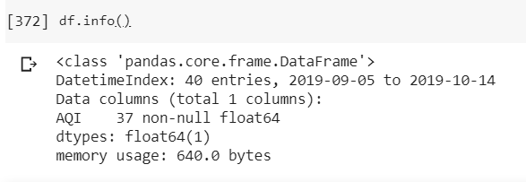

This dataset records AQI index from 05-09-2019 to 11-10-2019. There are 3 null values as shown in the following figure

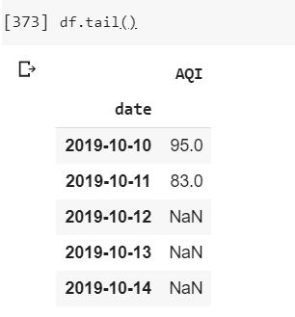

1. Preprocessing

We scale AQI values into floating number between 0 and 1.

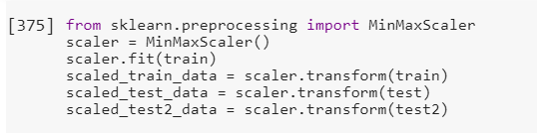

1. Define LSTM model

We use LSTM to predict AQI value. Firstly, we generate the input to the model using **TimeseriesGenerator**. AQI values from previous 3 days is used to predict AQI value of the next day.

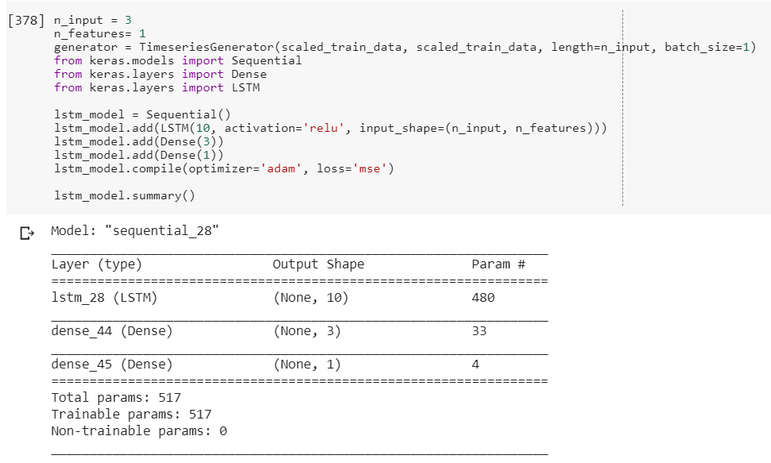

1. Train LSTM model.

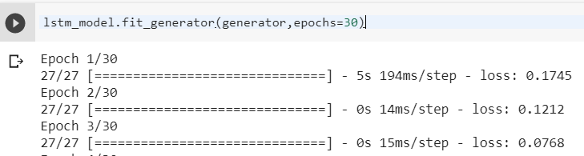

Loss value is shown in the following figure.

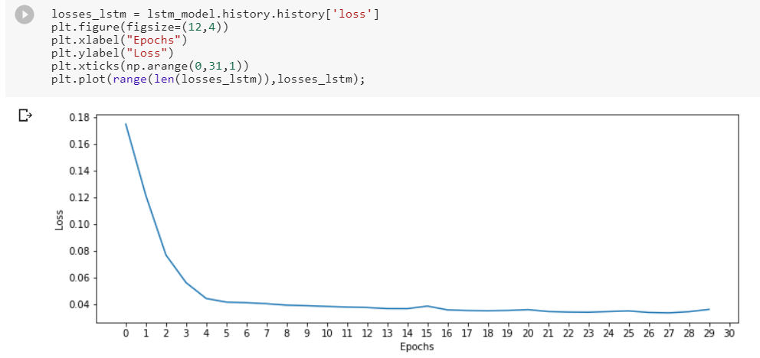

1. Testing and Predicting

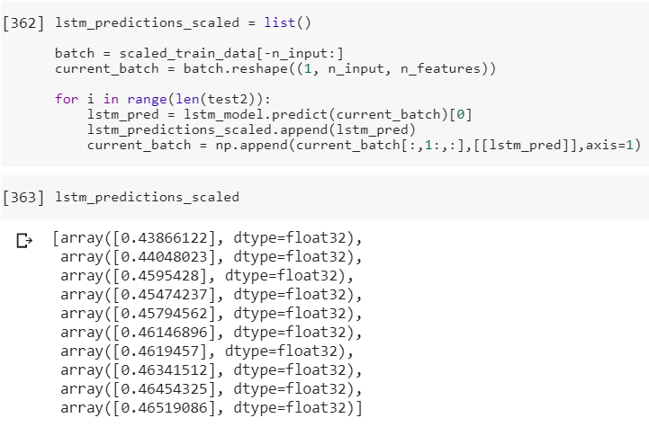

The output is rescaled back as follows.

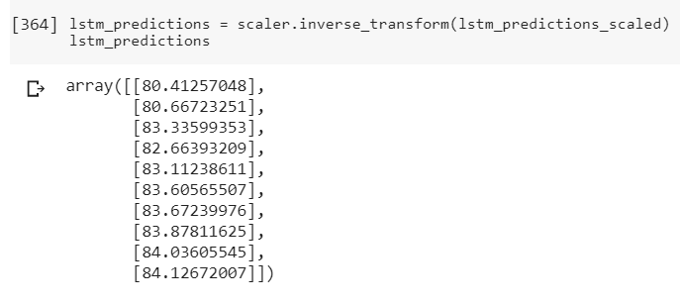

1. The predicted AQI values from 5-10-2019 to 13-10-2019 is shown in the following figure.

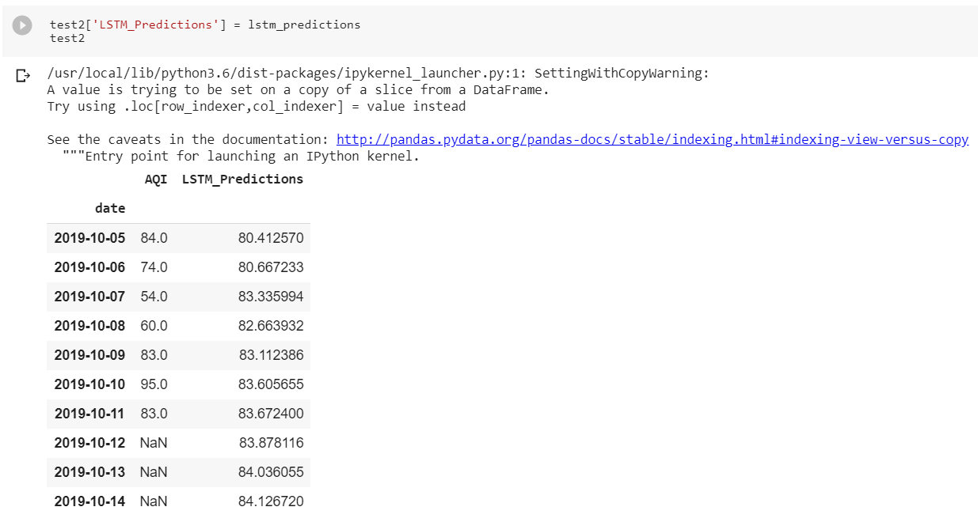

1. Plotting time series and calculating MAE

